**HTM Questionnaire**

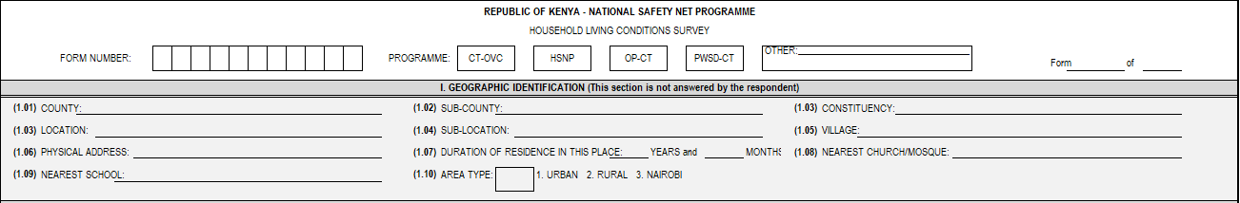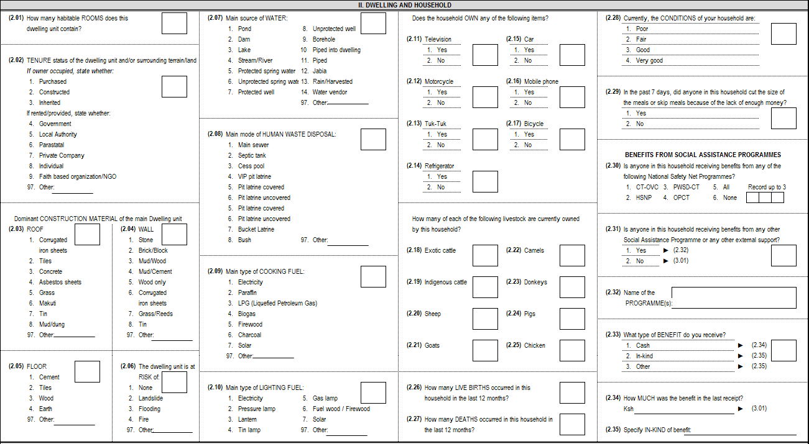

**to**

**Proxy Means Test (PMT)**

The regression-based proxy means test (PMT) approach is used to estimate consumption based on actual consumption data from the Kenya Integrated Budget Household Survey (KIHBS) in 2015/16. As this survey records both household characteristics and consumption, multiple regression analysis can be used to estimate the relationship between household characteristic variables and the monetary value of household consumption. Given the likely differences in the relationships between household characteristics and consumption across different areas, three separate models are estimated:

* 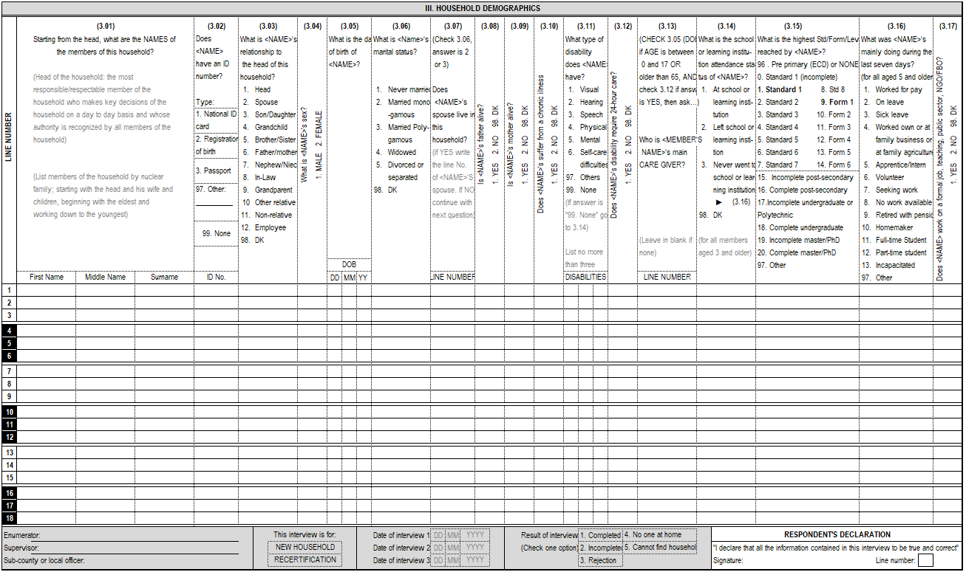All rural areas
* All urban areas except Nairobi
* Nairobi

The possible household characteristic variables are modelled using the available information collected in the Harmonized Targeting Tool registration questionnaire. For each of the three models the potential variables go through a selection process, which first keeps variables which are correlated with log consumption. Secondly, the correlated variables are included in a backward stepwise regression model, which removes variables that do not have a significant statistical relationship with log consumption. Finally, variables with a variance inflation factors, which checks for multicollinearity, from the stepwise regression greater than 10 are also excluded. The remaining variables are those that are included in the PMT models. From the estimated PMT regression model, PMT scores for each observation can be calculated, which estimates log consumption. These scores can be normalized across the three models and used to order households based on their estimated consumption. The coefficients for each of the PMT models can be found below and can be used to produce PMT scores. The PMT model and coefficients are recommended to be updated once new household budget survey data becomes available.

**PMT Formula – Nairobi**

|  |  |  |
| --- | --- | --- |
| Variable | Definition | Coefficient |
| Hh_TV_proxy | Does the household own a TV? 0 – No, 1 - Yes | 0.131 |
| Owns_fridge | Does the household own a refrigerator? 0 – No, 1 – Yes. | 0.257 |
| Hh_size | Household size | -0.121 |
| Hh_rooms_proxy | Number of rooms per person. | 0.286 |
| Hh_wall_proxy | 0 = No walls, other. 1 = Cane/Palm/Trunks, Grass/Reeds. 2 = Corrugated Iron Sheets. 3 = Mud, Bamboo with Mud, Uncovered Adobe. 4 = Wood Planks/Shingles, Plywood, Cardboard, Reused Wood. 5 = Cement, Cement Blocks, Stone with Lime/Cement. 6 = Bricks, Covered Adobe. 7 = Stone with Mud. | 0.0588 |
| Owns_car | Does the household own a car? | 0.538 |
| Hh_toilet_proxy | 0 = other, flush to somewhere else, flush to unknown place/not sure/dk where, composting toilet, hanging toilet/hanging latrine. 1 = No facility/bush/field. 2 = Bucket toilet. 3 = Pit latrine without slab/open pit. 4 = Pit latrine with slab. 5 = Ventilated improved pit latrine. 6 = Flush to pit (latrine). 7 = Flush to septic tank. 8 = Flush to piped sewer system. | 0.0204 |
| Hh_eduhead_proxy1 | Completed education level of the household head. 0 – None. 1 – Primary. 2 – Secondary. 3 – Tertiary. | 0.0936 |
| Constant |  | 8.843 |

**PMT Formula – Urban**

|  |  |  |
| --- | --- | --- |
| Variable | Definition | Coefficient |
| hh_TV_Proxy | Does the household own a TV? 0 – No, 1 - Yes | 0.165 |
| Owns_motorcycle | Does the household own a motorcycle? 0 – No. 1 – Yes. | 0.115 |
| Hh_edumax_proxy1 | Maximum completed education level for the household. 0 – None. 1 – Primary. 2 – Secondary. 3 – Tertiary. | 0.0424 |
| Hh_lighting_proxy | 0 = Other, Generator, Candles, Biogas, Battery Lamp/Torch. 1 = Fuel Wood. 2 = Gas Lamp. 3 = Paraffin Tin Lamp. 4 = Paraffin Lantern. 5 = Paraffin Pressure Lamp. 6 = Electricity Connection from mains. 7 = Solar Energy. | 0.0203 |
| Own_fridge | Does the household own a refrigerator? 0 – No, 1 – Yes. | 0.148 |
| Hh_male | Proportion of male members. | -0.107 |
| Hh_size | Household size. | -0.0720 |
| Hh_children6 | Proportion of the household that are children under 6. | 0.175 |
| Hh_headage | Age of the household head. | -0.00332 |
| Hh_malehead | Male household head. | 0.168 |
| Hh_spouse | Household has a spouse. | -0.201 |
| Hh_rooms_proxy | Number of rooms per person. | 0.146 |
| Hh_roof_proxy | 0 = Other. 1 = Dung/Mud. 2 = Grass/Thatch/Makuti. 3 = Tin Cans. 4 = Corrugated Iron Sheets. 5 = Asbestos Sheets. 6 = Tiles/Concrete. | 0.0793 |
| Hh_floor_proxy | 0 = Other, dung. 1 = Earth/Sand. 2 = Wood planks/Shingles, Palm/Bamboo, Parquet or polished wood. 3 = Cement. 4 = Ceramic Tiles, Vinyl or Asphalt Strips, carpet. | 0.0606 |
| Owns_car | Does the household own a car? | 0.298 |
| Hh_toilet_proxy | 0 = other, flush to somewhere else, flush to unknown place/not sure/dk where, composting toilet, hanging toilet/hanging latrine. 1 = No facility/bush/field. 2 = Bucket toilet. 3 = Pit latrine without slab/open pit. 4 = Pit latrine with slab. 5 = Ventilated improved pit latrine. 6 = Flush to pit (latrine). 7 = Flush to septic tank. 8 = Flush to piped sewer system. | 0.0305 |
| Hh_cooking_proxy | 0 = Other, Straw/shrubs/grass, animal dung, agricultural crop residue. 1 = Firewood. 2 = Charcoal. 3 = Kerosene. 4 = Biogas. 5 = Liquified Petroleum Gas. 6 = Electricity | 0.0533 |
| Region_mombasa | From Mombasa. 0 – No. 1 – Yes. | 0.0896 |
| Region_coastal | From Kwale, Kilifi, Tana River, Lamu, Taita Taveta. 0 – No. 1 – Yes. | 0.139 |
| Hh_eduhead_proxy1 | Completed education level of the household head. 0 – None. 1 – Primary. 2 – Secondary. 3 – Tertiary. | 0.0595 |
| Hh_spouseworked_proxy | Working spouse. 0 – No. 1 – Yes. | 0.0469 |
| Hh_PWSD1564 | Any member 15-65 with disability. 0 – No. 1 – Yes. | -0.0631 |
| Hh_headmonogamous | Head of the household is monogamously married. 0 – No. 1 – Yes. | -0.0532 |
| Constant |  | 8.103 |

**PMT Formula – Rural**

|  |  |  |
| --- | --- | --- |
| Variable | Definition | Coefficient |
| Region_mid_eastern | Meru, Tharaka-Nithi, Embu. 0 – No. 1 – Yes. | 0.114 |
| Sheep | Number of sheep owned. | 0.00478 |
| Region_nyanza_western_leastern | Kitui, Machakos, Makueni, Kakamega, Vihiga, Bungoma, Busia, Siaya, Kisumu, Homa Bay, Migori, Kisii, Nyamira. 0 – No. 1 – Yes. | -0.0493 |
| Region_north_rift | Turkana, West Pokot, Sambura. 0 – No. 1 – Yes. | -0.259 |
| Hh_tv_proxy | Does the household own a TV? 0 – No, 1 - Yes | 0.153 |
| Owns_motorcycle | Does the household own a motorcycle? 0 – No. 1 – Yes. | 0.124 |
| Exo_cattle | Number of exotic cattle owned. | 0.0248 |
| Hh_edumax_proxy1 | Maximum completed education level for the household. 0 – None. 1 – Primary. 2 – Secondary. 3 – Tertiary. | 0.0729 |
| Hh_lighting_proxy | 0 = Other, Generator, Candles, Biogas, Battery Lamp/Torch. 1 = Fuel Wood. 2 = Gas Lamp. 3 = Paraffin Tin Lamp. 4 = Paraffin Lantern. 5 = Paraffin Pressure Lamp. 6 = Electricity Connection from mains. 7 = Solar Energy. | 0.0240 |
| Hh_headworked_proxy | Working household head. 0 – No. 1 – Yes. | 0.0370 |
| Owns_fridge | Does the household own a refrigerator? 0 – No, 1 – Yes. | 0.176 |
| Hh_dependent | Dependency ratio – Under 15s & Over 65’s divided by Individuals between 15 and 65. | -0.0165 |
| Hh_male | Proportion of male members. | -0.0866 |
| Hh_size | Household size. | -0.0698 |
| Hh_children6 | Proportion of the household that are children under 6. | 0.337 |
| Hh_headage | Age of the household head. | -0.00363 |
| ind_camel | Number of camels owned. | 0.0134 |
| Owns_mobile | Household owns a mobile. 0 – No. 1 – Yes. | 0.129 |
| Owns_bicycle | Household owns a bicycle. 0 – No. 1 – Yes. | 0.0543 |
| Hh_malehead | Male household head. | 0.156 |
| Hh_spouse | Household has a spouse. | -0.161 |
| Hh_dwelling_proxy | 0 = House gifted, bartered for, or other mode of acquiring, rent paid directly to company, rent paid through an agent, rent paid to other, squatting. 1 = Rent paid to individual directly, rent paid to an individual through an agent, no rent with consent of owner. 2 = Rent paid to national government. 3 = Rent paid to county government or parastatal. 4 = Constructed with cash, constructed with a loan, constructed with cash and a loan. 5 = Inherited. 6 = Purchased cash, purchased with a loan, purchased with cash and loan. | 0.0209 |
| Hh_rooms_proxy | Number of rooms per person. | 0.12 |
| Hh_wall_proxy | 0 = No walls, other. 1 = Cane/Palm/Trunks, Grass/Reeds. 2 = Corrugated Iron Sheets. 3 = Mud, Bamboo with Mud, Uncovered Adobe. 4 = Wood Planks/Shingles, Plywood, Cardboard, Reused Wood. 5 = Cement, Cement Blocks, Stone with Lime/Cement. 6 = Bricks, Covered Adobe. 7 = Stone with Mud. | 0.0279 |
| Hh_roof_proxy | 0 = Other. 1 = Dung/Mud. 2 = Grass/Thatch/Makuti. 3 = Tin Cans. 4 = Corrugated Iron Sheets. 5 = Asbestos Sheets. 6 = Tiles/Concrete. | 0.0295 |
| Hh_floor_proxy | 0 = Other, dung. 1 = Earth/Sand. 2 = Wood planks/Shingles, Palm/Bamboo, Parquet or polished wood. 3 = Cement. 4 = Ceramic Tiles, Vinyl or Asphalt Strips, carpet. | 0.019 |
| Owns_car | Does the household own a car? 0 – No. 1 – Yes. | 0.256 |
| Hh_toilet_proxy | 0 = other, flush to somewhere else, flush to unknown place/not sure/dk where, composting toilet, hanging toilet/hanging latrine. 1 = No facility/bush/field. 2 = Bucket toilet. 3 = Pit latrine without slab/open pit. 4 = Pit latrine with slab. 5 = Ventilated improved pit latrine. 6 = Flush to pit (latrine). 7 = Flush to septic tank. 8 = Flush to piped sewer system. | 0.013 |
| Hh_cooking_proxy | 0 = Other, Straw/shrubs/grass, animal dung, agricultural crop residue. 1 = Firewood. 2 = Charcoal. 3 = Kerosene. 4 = Biogas. 5 = Liquified Petroleum Gas. 6 = Electricity | 0.0729 |
| Constant |  | 7.956 |